**ASSIGNMENT-3**

**Name: Gutti Manjeera**

**Reg no: 310119104034**

**College Name:**  **Anand Institute of Higher Technology**

**PROGRAM FOR TRAFFIC LIGHT**

**Python Code:**

**void setup() {**

**// put your setup code here, to run once:**

**Serial1.begin(9600);**

**pinMode(21, OUTPUT);**

**pinMode(20, OUTPUT);**

**pinMode(19, OUTPUT);**

**}**

**void loop() {**

**// put your main code here, to run repeatedly:**

**digitalWrite(21, HIGH);**

**delay(3000); // this speeds up the simulation**

**digitalWrite(21, LOW);**

**digitalWrite(20, HIGH);**

**delay(3000);**

**digitalWrite(20, LOW);**

**digitalWrite(19, HIGH);**

**delay(3000);**

**digitalWrite(19, LOW);**

**}**

**OUTPUT:**

**Traffic Lights For Raspberry Pi**

**Blinking Red Light:**

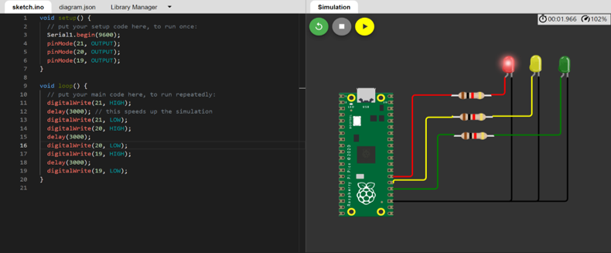

**Blinking Yellow Light:**

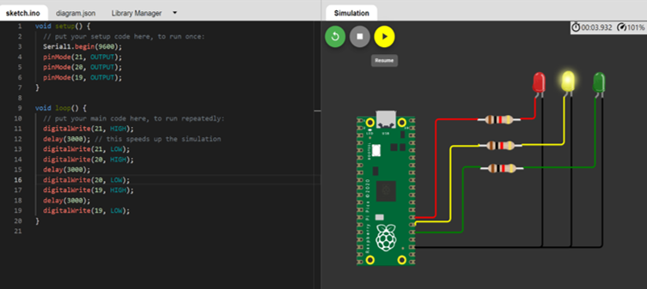

**Blinking Green Light:**

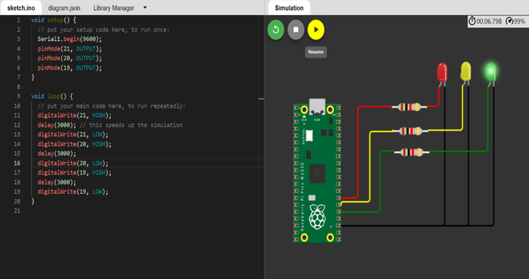

**BLINKING LED:**

**PROGRAM FOR BLINKING LED:**

**Python code:**

**void setup() {**

**// put your setup code here, to run once:**

**Serial.begin(9600);**

**pinMode(22, OUTPUT);**

**}**

**void loop() {**

**// put your main code here, to run repeatedly:**

**digitalWrite(22, HIGH);**

**Serial.println("LED ON");**

**delay(2000);**

**digitalWrite(22, LOW);**

**Serial.println("LED OFF");**

**delay(2000);**

**}**

**Output:**

**Blinking LED For Raspberry pi:**

